AluMag organized Asia Automotive Lightweight Procurement Symposium 2015 - a great success
The 2nd International Asia Automotive Lightweight Procurement Symposium, organized by AluMag from the 6th – 8th of July 2015 at the Jumeirah Himalayas Hotel in Shanghai, China, turned out to be a great success. With the number of participants growing and level of internationality surpassing that of the previous year, it set an all new benchmark for events of the same caliber. Over a hundred professionals from numerous OEM, Tier 1, Tier 2 equipment manufacturers and independent consultants attended the event. AlCircle as the official online media partner was privileged to cover the whole event. From Day 1 till the end of the symposium, the team was witness to all the activities and insightful presentations that were made there.
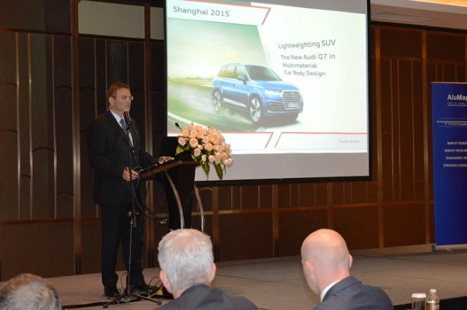
The conference was formally started on July 7 with a short welcome speech by AluMag Automotive GmbH Managing Partner Mr. Jost Gaertner. The eminent speakers who took the dais after him were Mr. Frank Venier from Audi AG in charges of Strategy and Innovation Lightweight Design Centre, Mr. Gerhard Krachler from Magna Steyr Engineering AG & Co KG and Mr. Christian Juricek from Magna Cosma International, and Jochen Siebert the Managing Partner from JSC Automotive Consulting Co. Ltd. There were representatives from Kurtz GmbH, Voestalpine Metal Forming GmbH, DGS Druckguss Systeme AG, and Guangdong Hongtu Technology (Holdings) Co., Ltd as well.
All the delegates made impressive speeches on topics related to lightweighting and its prospects in automotive industry.
Mr. Frank Venier spoke on lightweighting SUV- the new Audi Q7 in multimaterial car body design. He started with highlighting Audi's 2020 corporate strategy at the backdrop of present automotive market scenario and then went on to explain how the degree of lightweighting and its complexity increases with each level of designing process.
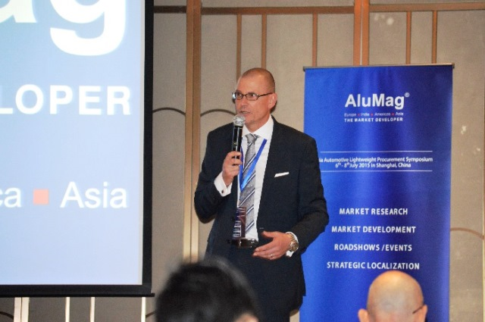
Next speaker Mr. Gerhard Krachler made a presentation on Magna’s global advanced lightweight competences. His ambit of discussion included an introduction to intelligent lightweighting and its impact on new vehicle requirements and life cycle analysis of eco design along with total costs of ownership.
Other topics that were discussed on July 7 included- localization and industrialization of cast aluminium structural applications by Mr. Andreas Mueller; aluminum alloy high vacuum die casting technology and it’s application on automotive structural parts by Mr. Li Wan; outlook and hurdles of the Chinese economy and automotive industry by Mr. Jochen Siebert; and profits with light metal castings start in the melt shop, jointly by Mr. Rudolf Riedel and Mr. Rainer Erdmann. Day 3 of the Symposium saw Mr. Yoshikazu Mukai from Kobelco Automotive Aluminium Rolled Products (China) Co., Ltd – Shanghai Branch and Mr. Martin Shi from Gasgoo making splendid speeches soon after Prof. Fei Xiong the Chief Engineer & Director of Auto Lightweight Department at Geely welcomed the audience with his opening keynote on automotive lightweight promoting the application of aluminium.
Other speakers who made valuable presentations on July 8 were Mr. James Liu, Managing Director and Vice President of Asia Auto at Novelis China, Dr. Jin Hou, General Manager- Sapa Technology Asia, and Mr.Yoshikazu Mukai, Executive Vice President & Technical Specialist at Kobelco Automotive Aluminium Rolled Products (China) Co,. Ltd – Shanghai Branch.
The event ended with Mr. Gaertner conveying gratitude to all present. He also summarized all the discussions held in the three day Symposium.
Asia Automotive Lightweight Procurement Symposium 2015 was successful in bringing all top notch officials of the industry under the same roof. Participation grew 10 per cent over the last year, of which 65 per cent was from Asia. It has set the perfect stage now for the next AluMag Automotive Lightweight Procurement Symposium to be held from November 9th through the 11th, 2015 in Detroit. It will be focused on the NAFTA market, and AlCircle looks forward to be a part of it once again.

http://www.alcircle.com

